INTEGRATIVE COURSE IN PSYCHOLOGY (ICOPSYCH)

ANALYSIS ON THE RESULT OF PRE-TEST EXAMINATION IN PSYCHOLOGICAL ASSESSMENT
MAY 31, 2025

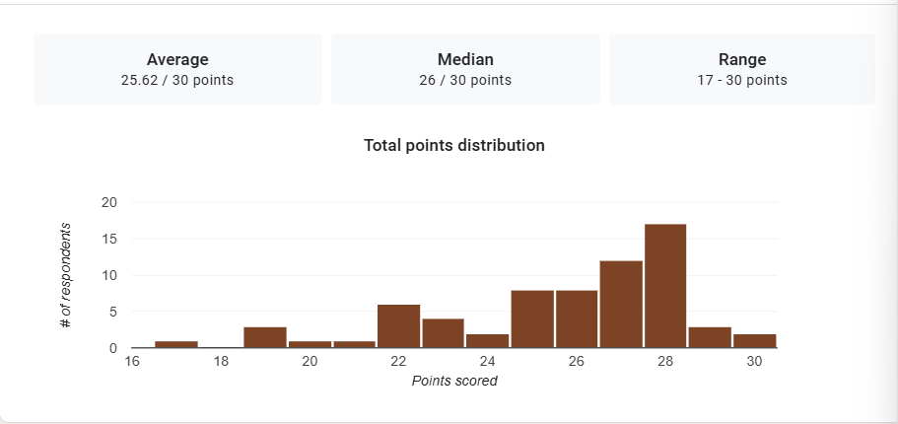

1. Mean Score: The mean score of 25.62 suggests a high overall performance. This corresponds to 85.4%, indicating that the majority of test-takers have a strong understanding of the tested material.

2. Median Score: The median score of 26 is slightly higher than the mean. This indicates a slightly left-skewed distribution; where most students performed well, but a few lower scores (closer to 17) slightly reduced the mean.

3. Range: The range of 13 points (from 17 to 30) shows moderate variability in performance. The lowest score of 17 still reflects more than 50% of the total points, which implies that even the lowest performers had a basic grasp of the material.

Interpretation Summary:

-The test results indicate a high level of achievement, with both the mean (25.62) and median (26) close to the maximum score.

-The moderate range (17–30) reflects some variation in performance, but no extremely low scores.

-Overall, the group demonstrated strong understanding, with only a small gap between the highest and lowest performers.

RATIONALIZATION:

DIFFICULT QUESTIONS:

